APM

2(a)

Deeland is a stable country with low inflation and interest rate.General rate of inflation can reflect that Deeland is a stable country.The general rate of inflation can be used to compare with the one in Jayland to evaluate if Jayland is also a stable country.

Monoply legislation in Deeland is strict.Market share can reflect if Backetts is probable to breach the monoply legislation.However,Jayland government only stipulates that foreign business should form joint venture with local business,not mentioning monoply legislation.The KPI of market share may not measure the performance in Jayland well.

Environmental law in Deeland is strict,thus,it is effective to use number of breaches of environmental legislation to measure the performance.However,Jayland has a poor record of pertecting environment and doesn’t care if economic growth will affect environmental damage.Number of breaches of envirnmental legislation is not suitable for performance measurement in Jayland.

For Jayland,a KPI to reflect joint venture with local business is necessary.The number of local business that is willing to form joint venture can be used to measure the performace.GDP can be used to measure the economic growth of Jayland.

(b)The two objectives are:

-To take advantage of increases in income and population movement in Jayland

-Develop the Becketts brand, chain of stores and range of products sold to appeal to the tastes, expectations and geographical convenience of stores for customers in Jayland

For the first objective,increases in income and population mean that both of sales volumes and sales prices of Becketts’ product can increase.The sales volumes of necessities can be used as a KPI to see if Becketts seive the opportunity of population growth.Total revenue can be used to measure if the increase of income cause citizens to spend more.

For the second objective,as transport infrastructure is often inadequate in Jayland,time spent for local citizens to get the stores should be measured to see if geographical convenience is achieved.In addition,most citizens in Jayland is slow to adopt to new brands and prefer familiar goods.Repurchase rate can be used to see if local customers has accepted our products.

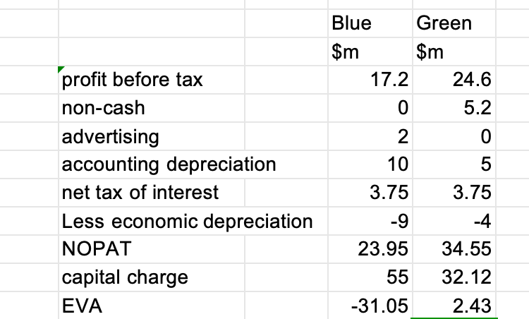3(a)

EVA of Blue Co is negative,suggesting that the value of Blue Co is decreasing.Likewise,the value of Green Co is increasing.

As the objective of Luffield is to maximise shareholders’ wealth,EVA is more suitable than ROCE because it is in line with shareholders’ expectation.It encourages expenditure in areas that create benefit for the long term.

ROCE focus more on short-term performance.Blue and Grenn’s current performance are poor.If use ROCE as the indicator,future potential may be ignored.Therefore,EVA is better than ROCE to measure divisional performance.

(b)VBM begins from the view that the value of a company is measured by its discounted future cash flows.VBM focuses the management of the company on thoses areas which create value.A key to this process is the identification of the value drivers and then a concentration of effort at all levels(operational to strategic)on these drivers to create the value of the firm.

In order to improve the performance of Luffield,VBM suggets that a strategy of maximizing the value should be generated.Lufield’s strategy of acquiring new retail business and disposing underperforming ones focuses more on short-term benefit,not creating long-term value.Luffield should develop a strategy which takes long-term value and value drivers into consideration.

Then,performance targets under the strategy should be defined and plan to achieve the targeys should be created.A measurement and reward system should be set up to motivate staff and improve performance.The board of directors can be awarded a bonus for meeting the targets of EVA,not EPS.

Blue and Green should also follow the strategy set and align with the plan.Blue should obey the regulation and win the reputation to create value.Green should develop its electricity delivery vehicles and reduce its costs.